**8. COLPITTS OSCILLATOR**

**AIM**: To determine the frequency of oscillations of the Colpitts oscillator.

**APPARATUS**

1. Transistor BC 107,
2. Capacitors – 10μf (2) & 330pf (1) & 100uf (1),
3. Resistors – 10KΩ (1), 100Ω (1) & 22KΩ (1),
4. Inductor – 0.33mH (1),
5. Decade Capacitance Box,
6. Potentiometer – 10K (1),
7. Regulated Power Supply,
8. Bread Board & Connecting Wires.

**CIRCUIT DIAGRAM** :

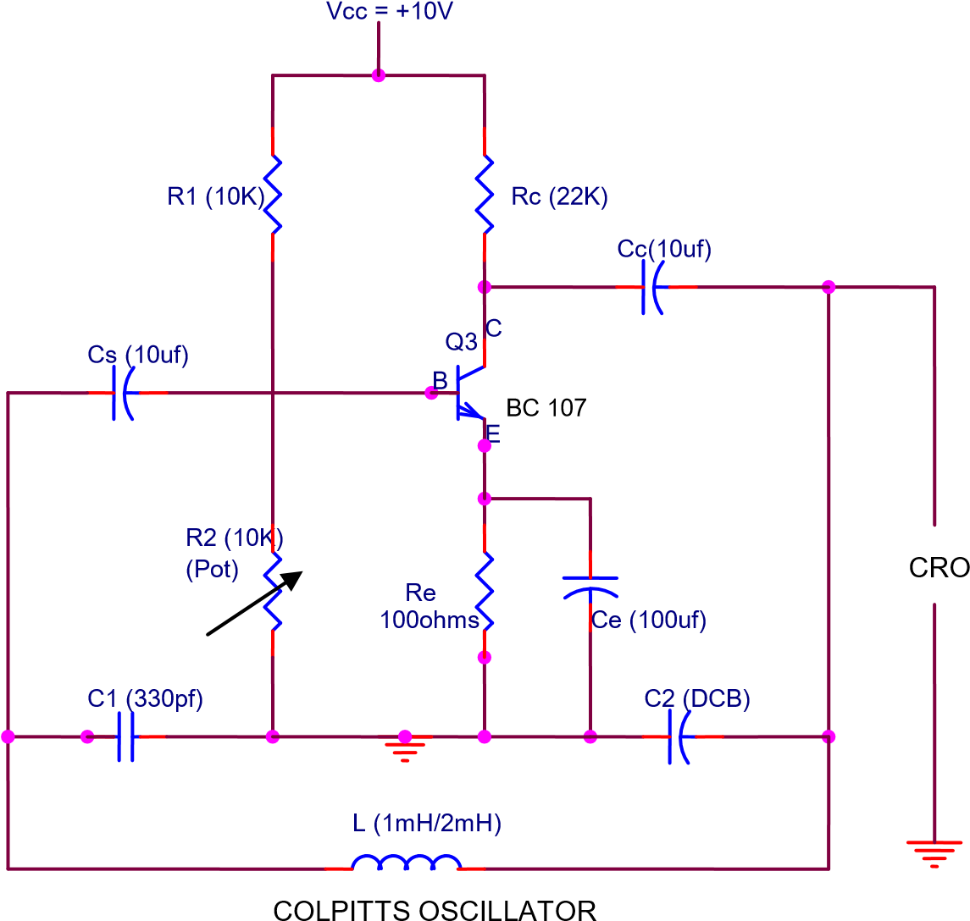

**PROCEDURE** :

1. The circuit is connected as shown in figure.
2. The capacitor C1 is kept constant and C2 is up to some value.
3. The resistor R2 is adjusted until sinusoidal waveform is observed on the CRO.
4. Then the time period and hence the frequency are calculated which is nearly equal to the theoretical frequency.
5. The theoretical and practical values of frequency are verified using the formula. **fo = 1 / 2П √ LCeq** where **Ceq = C1C2**

**C1+C2**

**fo practical = 1 /T (Hz) T = Time period.**

1. The experiment is repeated for different values of C2.

**OBSERVATION** :

CIRCUIT DIAGRAM

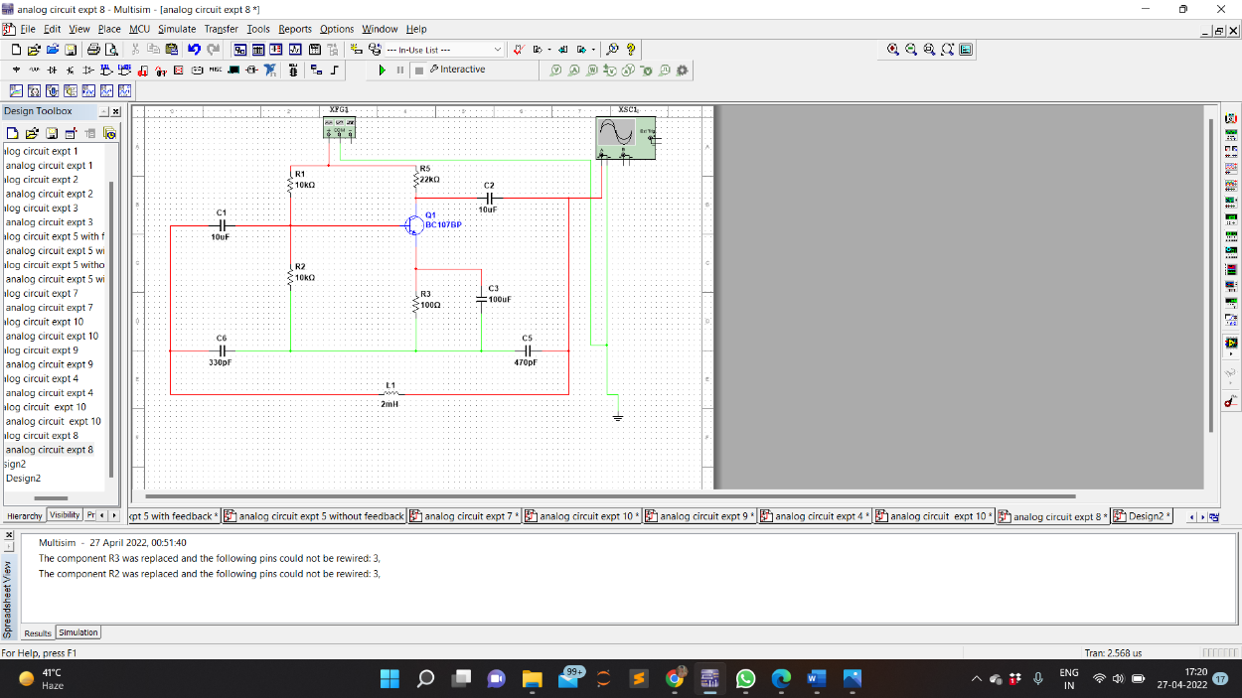

WAVEFORM

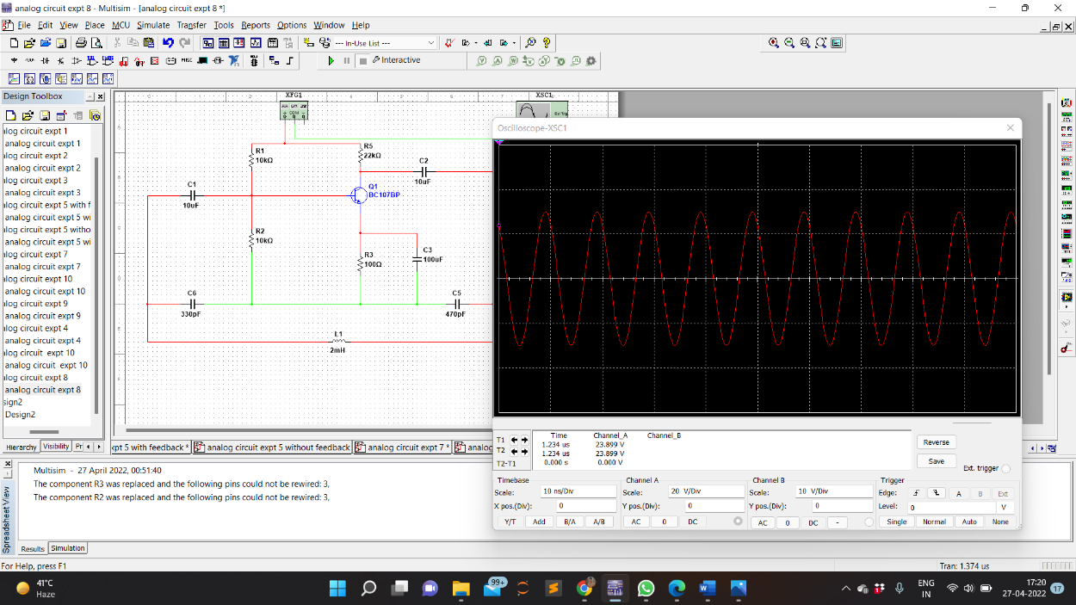

**CALCULATION**

1. **L = 2 mH**

**C1 = 330pf**

**C2 = 330pf**

**Ceq = (330x330)/(330+330) = 165pf**

**f = 1/2П √ LCeq = 277.193 KHz**

1. **L = 2 mH**

**C1 = 330pf**

**C2 = 470pf**

**Ceq = (330x470)/(330+470) = 193.875pf**

**f = 1/2П √ LCeq = 260.875 KHz**

1. **L = 2 mH**

**C1 = 330pf**

**C2 = 570pf**

**Ceq = (330x570)/(330+570) = 209pf**

**f = 1/2П √ LCeq = 251.303 KHz**

**TABULAR FORM :**

|  |  |  |  |  |  |  |
| --- | --- | --- | --- | --- | --- | --- |
| **S.NO.** | **INDUCTANCE**  **(L)** | **CAPACITANCE** | | | **Theoretical fo=1/2П √ LCeq**  **(kHz)** | **T**  **(Sec)** |
| **C1** | **C2** | **Ceq** |
| **1.**    **2.**    **3.** | **2mH**    **2mH**    **2mH** | **330pf**    **330pf**    **330pf** | **330pf**    **470pf**    **570pf** | **165pf**  **193.875pf**  209pf | **277.193**  **260.875**  **251.303** | **0.0036**  **0.0038**  **0.0039** |

|  |  |
| --- | --- |
| **PRECAUTIONS** | **:**  1. Avoid loose and wrong connections. |
|  | 2. The sinusoidal waveform obtained must be distortion. |
|  | 3. Readings should be taken without parallax error. |
| **RESULT** |  |

Frequency of oscillations of the Colpitts oscillator is been studied and calculated from the designed circuit.